AM000-Asia-China-Han-Four Bat-Eight Arc

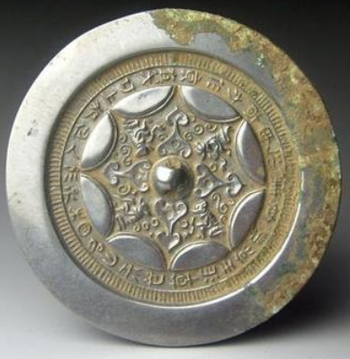

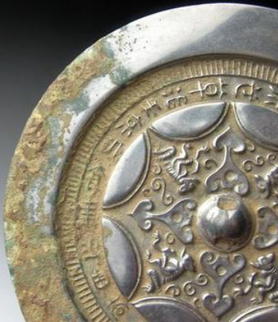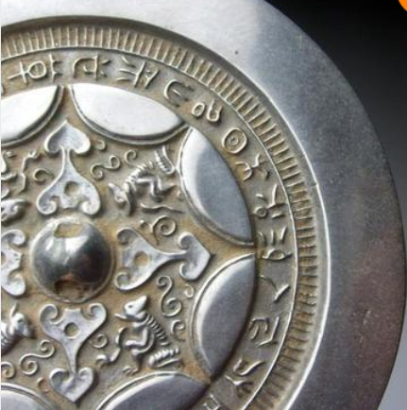

# Han Dynasty semicircle grass auspicious inscriptions bronze mirror 5in